Visual SourceSafe 6.0 ColdFusion Project Check-In & Check-Out Procedures
For
FamiliesFirst Inc
Table of Contents:
Visual SourceSafe 6.0 ColdFusion Project Check-In & Check-Out Procedures 1
CFM Project Check-Out Steps 3
Managing your VSS Settings (from the VSS Client): 16
Managing your VSS Settings (from ColdFusion Studio): 21
Document your Source Code Changes whenever possible: 25
Change Management Process Flow Diagram 27
Appendix A – Dreamweaver MX 29

CFM Project Check-Out Steps
The FamiliesFirst Standard method for manipulating and managing ColdFusion Projects is ColdFusion Studio version 5 with Dreamweaver MX as an alternate method. ColdFusion Studio version 5 provides the best development environment for programmers to use whereas Dreamweaver MX provides a way for non-programmers to work with HTML based projects. The Visual SourceSafe Client must be used to perform some tasks that cannot be performed using either ColdFusion Studio v5 or Dreamweaver MX.
After launching the Visual SourceSafe 6.0 client program you will see this VSS Project layout:

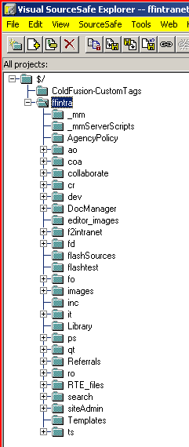

Locate and Select the VSS Project and then right click the mouse over the highlighted VSS Project and choose the Set Working Folder menu option, like this:

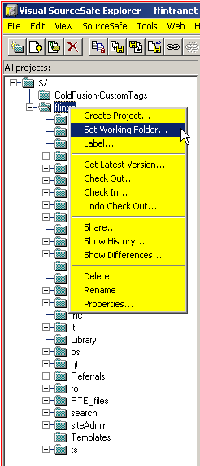

You will want to use the base folder that contains the files from FFintranet, for instance, which you may obtain from the I.T. Department and will look something like this (the actual place on your hard drive may differ depending on where you actually placed these files)
: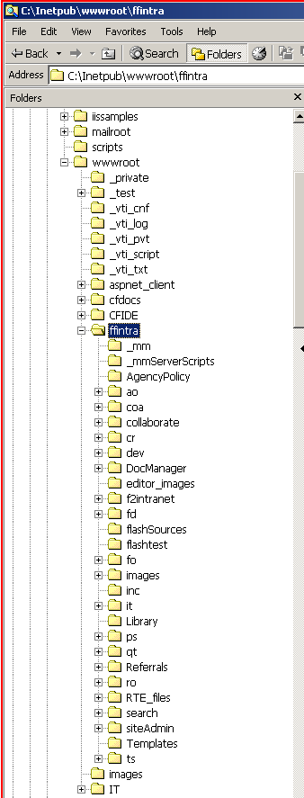
As you can see from this illustration, the place where these files were placed on my laptop computer is pretty much the same place they reside when installed on FFintranet. This is the best way to setup a ColdFusion Development Environment – a replica of the actual Production Environment but on a computer that lends itself more efficiently to the task of developing ColdFusion applications.
The Standard and Preferred way to do this is to use the ColdFusion Studio to help manage your ColdFusion Projects.

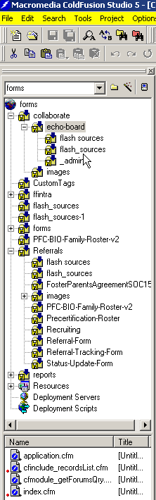
While using the ColdFusion Studio is the Standard and Preferred way to manipulate ColdFusion files it is possible to use the VSS Client to Check-out and Check-in and when you do so it goes something like this :
Check-Out the VSS files you wish to work with using the VSS Client, see below:
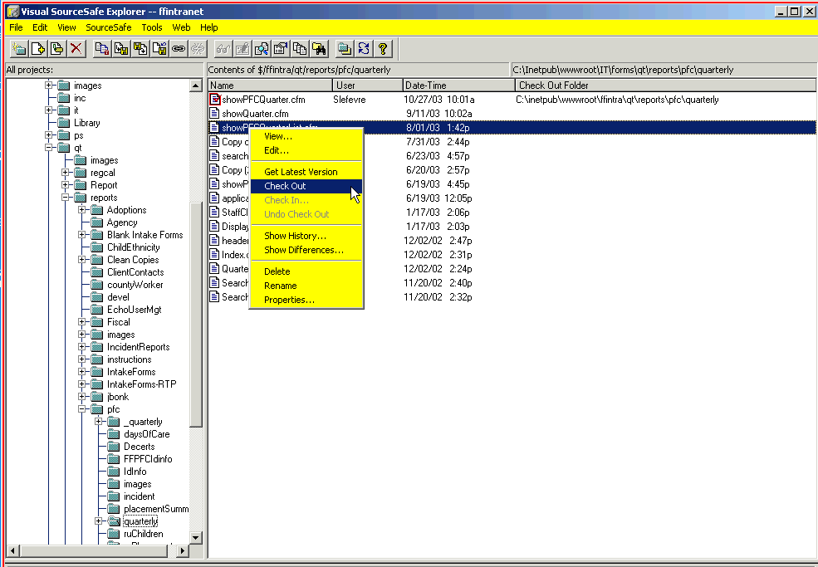
You must type in some useful comments using the format (YOUR Initials – today’s date MM-DD-YYYY – useful comments), see below: (PLS be sure to get into the habit of typing your comments into VSS whenever you check-out or check-in as doing so will help all of us track the changes being made.)
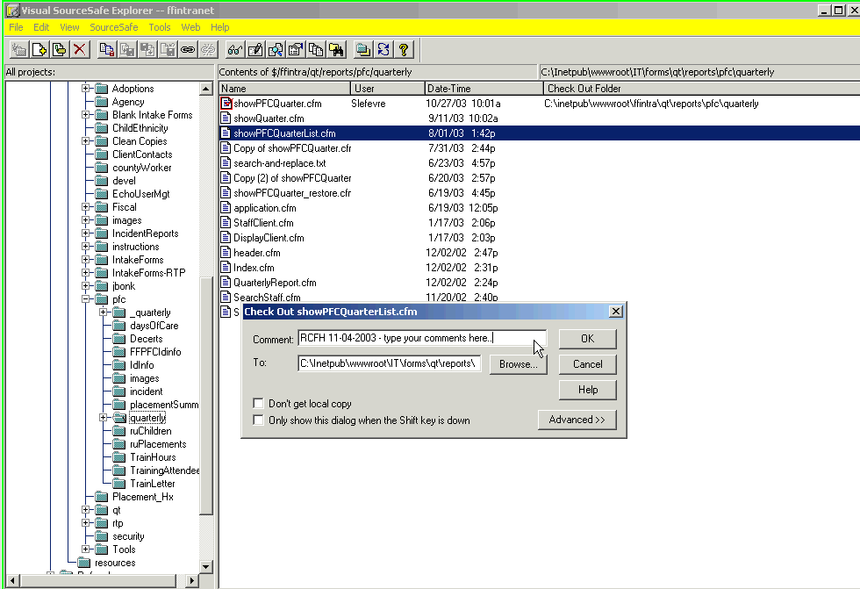
Click on the OK button.

The Standard way to check-out ColdFusion files is to use the ColdFusion Studio, see below:
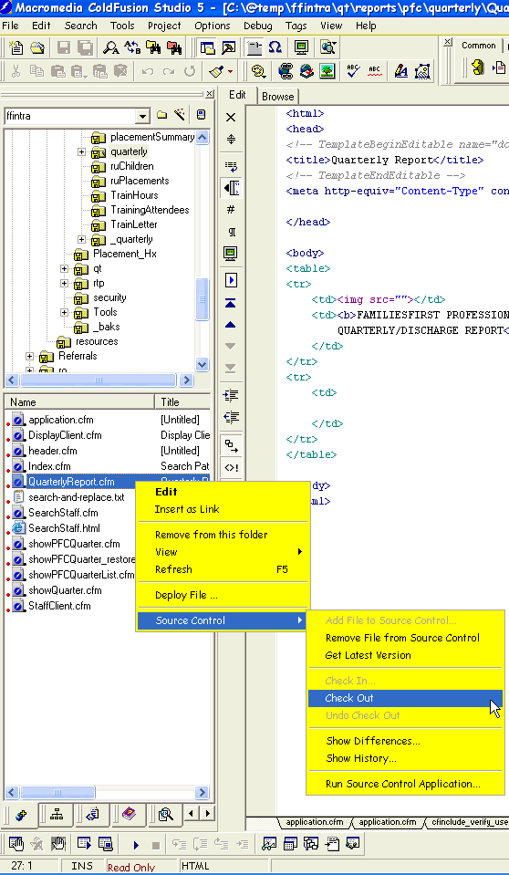
You may notice when files are checked-out using this method there is no prompt for any comments. You will be prompted to enter comments when Checking files back into VSS when using ColdFusion Studio v5. There is another required way for programmer comments to be captured and documented. This place is the Standard Comment Header which will be covered later on in this document.
ColdFusion Studio v5 works best within the current environment found here at FamiliesFirst; you may notice some warnings from Dreamweaver MX that have something to do with not being able to determine the server time. You should not get any such warnings from the ColdFusion Studio v5.

The current location of the shared VSS Repository is: (using VSS)

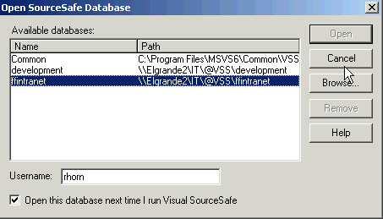
You may not be able to “Browse” to the path for the ffintranet VSS database due to security restrictions on the file server however you can simply enter the UNC path as shown in this illustration (above) :

To set the location of the shared VSS Repository using ColdFusion Studio :
Right click the mouse on the ffintra ColdFusion Studio Project and you shall see the following:
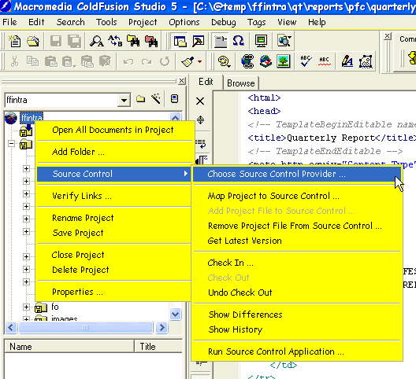
Click the mouse on the “Choose Source Control Provider…” menu item and you shall see the following:
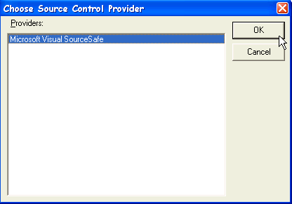
Then click the OK button.
Right click the mouse on the ffintra ColdFusion Studio Project again and you shall see the following:
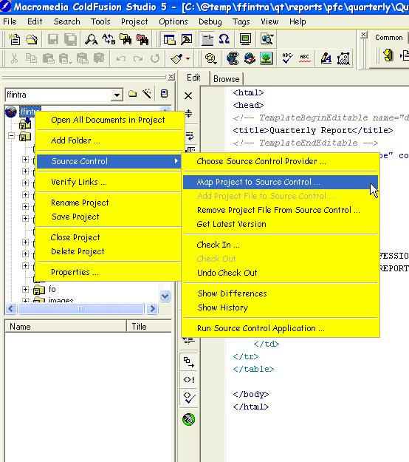
Click the mouse on the “Map Project to Source Control…” menu item and you shall see the following:
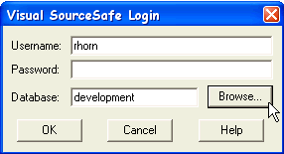
Click the mouse on the “Browse…” button and you shall see the following:
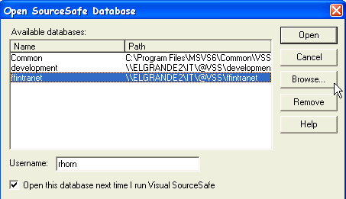
Click the mouse on the “Browse…” button and you shall see the following:
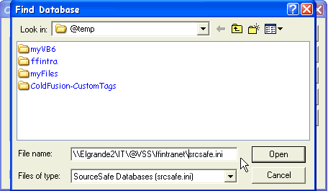 | This is where you type in the UNC path for the ffintranet VSS database.

Then hit the Open button and you shall see the following:
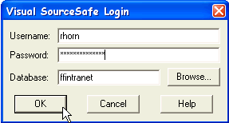
Now you type in your network password just as if you were logging in to any other FF_PDC1 resource and you shall see the following:
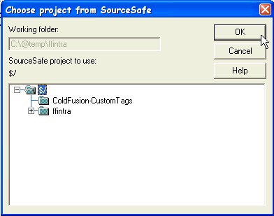 | Click on the $/ project name as shown above and then click the OK button.

Managing your VSS Settings (from the VSS Client):

Please ensure your own VSS Settings are correct as follows:

First locate the Tools Options Menu from the main pull-down menu bar, like this:
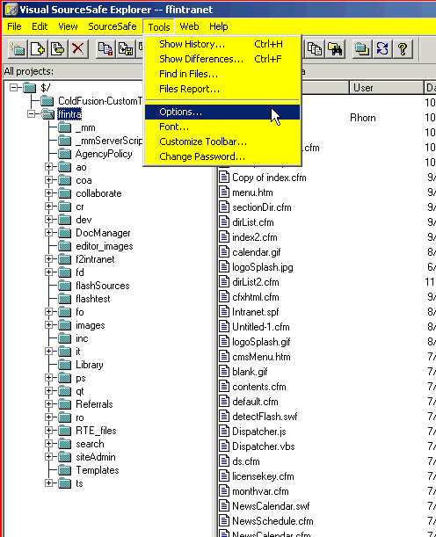

Click on the Tools Options menu item and next you will see the correct settings for the General tab, like this:
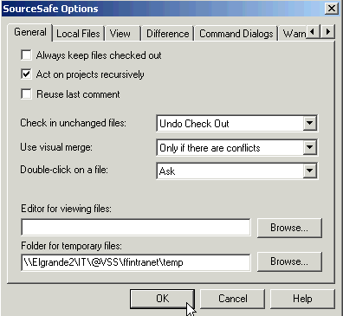
Click on the Local Files tab and you will see the correct settings, like this:
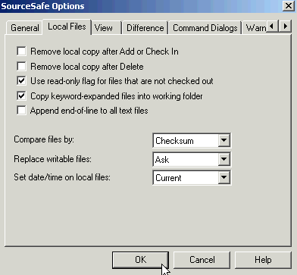
Click on the View tab and you will see the correct settings, like this:
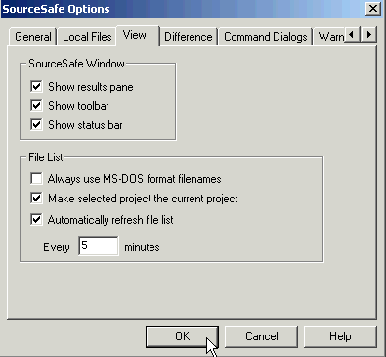
Click on the Difference tab and you will see the correct settings, like this:
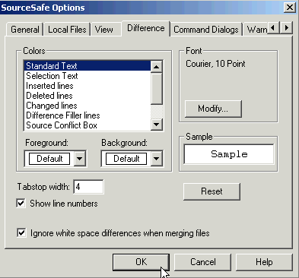
Click on the Command Dialogs tab and you will see the correct settings, like this:
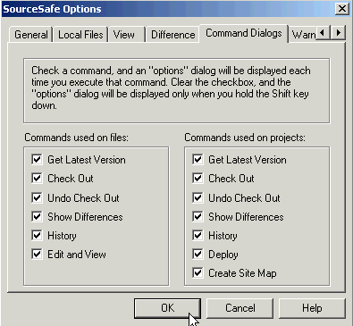
Click on the Warnings tab and you will see the correct settings, like this:
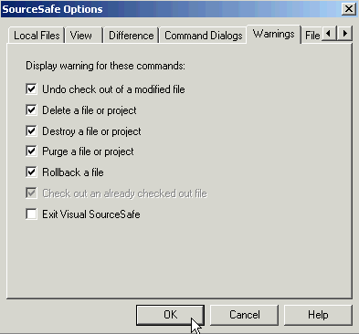
Click on the File Types tab and you will see the correct settings, like this:
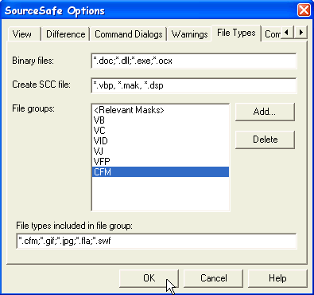
Click on the Command Line Options tab and you will see the correct settings, like this:
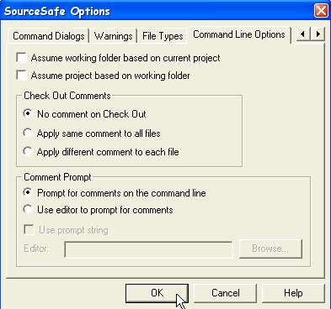

Managing your VSS Settings (from ColdFusion Studio):
Right click the mouse on the ffintra ColdFusion Studio Project again and you shall see the following:
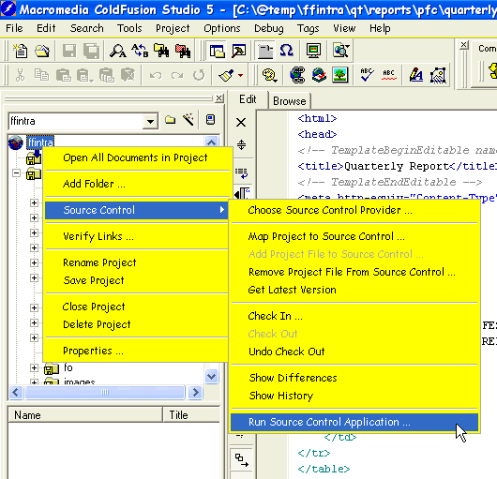
Click on the “Run Source Control Application…” menu item and follow the steps as specified in the previous section of this document titled “Managing your VSS Settings (from the VSS Client)”.
VSS Tips, Tricks and Shortcuts:
A fast way to Check-Out a VSS Project without having to Undo Check-Outs later goes something like this… Please keep in mind that while this procedure is faster than doing a Check-Out on an entire VSS Project it also does not flag the file(s) involved as having been checked-out until later on and this can potentially cause problems if other members of the team may be working on the same sets of files. On the other hand, you know best how to get your own work done so use whichever method you feel most comfortable with as long as the end result is properly manageable. Take it easy on the Team Librarian or VSS Administrator because that person may have to wade through a lot of possibly irrelevant instances of things that were checked-out and then never checked back in.
First, select the VSS Project you want to Check-Out and then right-click the mouse button and select the Get Latest Version pop-up menu options, like this: | 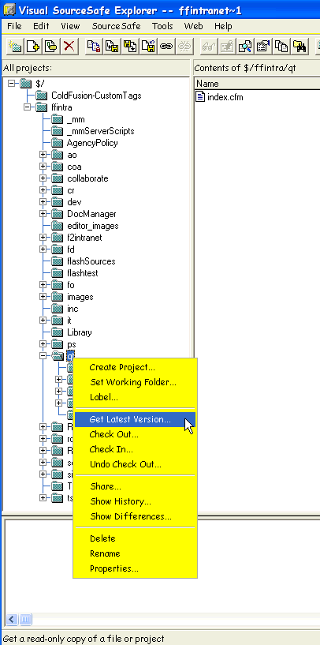
Then click on the Make Writable checkbox so VSS will allow you to modify or delete any of the files you just retrieved from VSS, like this:
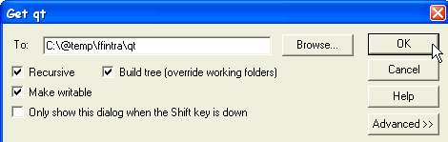

Then click on the OK button and the selected file(s) will be downloaded from VSS to your local hard drive. Your actual path for the “To:” entry field may differ from what you see in this illustration.
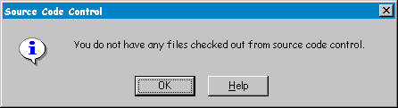
At this point you may begin working on these files and you may make whatever changes you wish to make however you must also Check-Out each modified file before VSS will allow a file Check-In and at that point you may encounter a dialog like this:

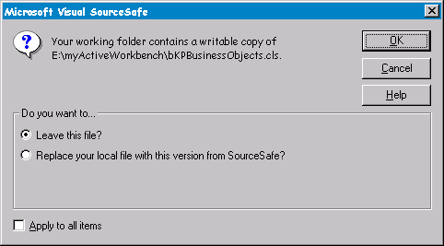
This is VSS’s way of letting you know you can’t do a Check-In unless you have previously done a Check-Out on a file-by-file basis however since you must do a Check-Out before doing a Check-In and this hasn’t been done yet and you have a modified file sitting on your hard drive and you don’t want to lose the changes you just made you will need to do a Check-Out for the modified file and when you see this:

And because you don’t want to lose your changes you would simply click the OK button with the Leave this file radio button selected.

Document your Source Code Changes whenever possible:
The name of the game for effective Source Code Control and Change Control is to document every change as much as possible whenever possible.
The many places you can document the changes which are via VSS if you are using VSS to perform your Check-Outs and Check-Ins or here :

<!--- *******************************************************************************************************************************
* FamiliesFirst Inc Standard Comment Block:
*
* Module Name: application.cfm
* Author: Ray Horn
* Date: 09/04/2003
*
* Modification History:
* Release 1.0 : 09/04/2003
* Release 2.0 : 09/25/2003 -- Converting to frames to make the flash index work better with fewer refreshes...
* *******************************************************************************************************************************
--->
This is the “FamiliesFirst Inc Standard Comment Block” and this must appear at the beginning of every single ColdFusion Source File you create or edit while you are performing your programming functions here at FamiliesFirst.
As you can see you need to enter correct information for each .CFM file in which you need to place this comment block. The Module Name is the name of the .CFM file. The Author is either your name if you created the .CFM file or the name of the original developer; use your name even if you know you did not write the .CFM file when you are adding this comment block to a file for the first time. The Date is the date the .CFM file was created but again use the current date when you are adding this comment block to a file for the first time. The Modification History is a running history of the changes made to each .CFM file, Add your comments to the list whenever making any kind of change to a .CFM file regardless of how minor the change was. Feel free to give details as per why the change was made.

Change Management Process Flow Diagram
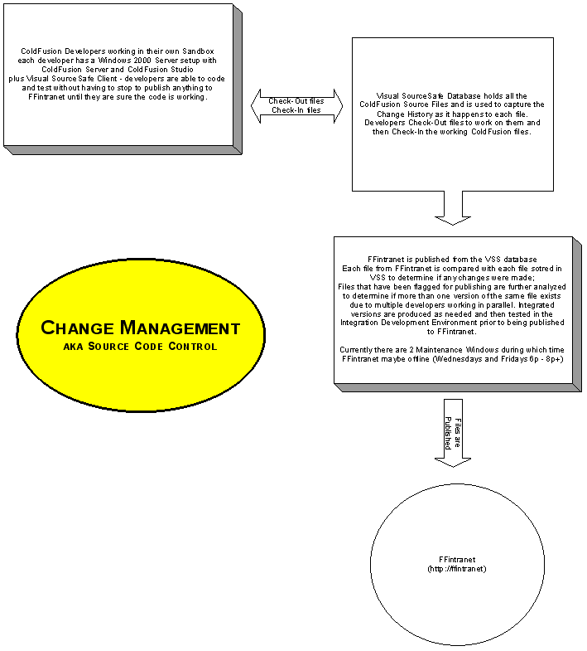
A few final notes…
If it’s not in VSS it doesn’t get published to FFintranet or any other Production Server and won’t be seen by anyone.

Appendix A – Dreamweaver MX
Macromedia Dreamweaver MX can be used to help manage your ColdFusion Projects however it is not the Preferred method.
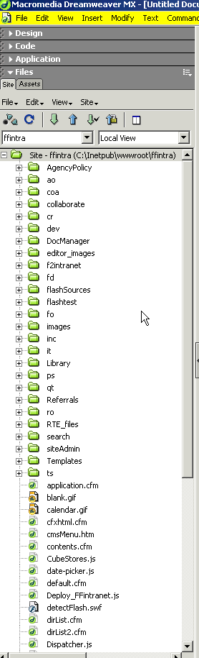
You may also Check-Out the VSS files you wish to work with using the Macromedia Dreamweaver MX, see below:
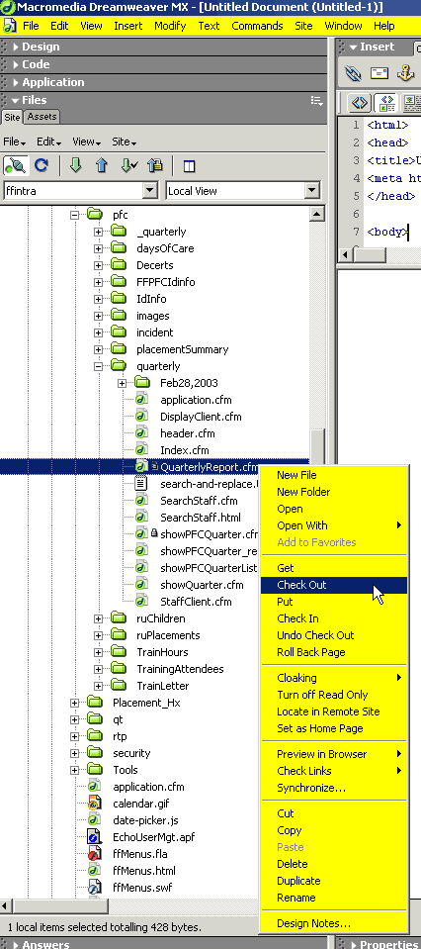

Managing your VSS Settings (from Macromedia Dreamweaver MX):
Macromedia Dreamweaver MX does not have a built-in way to manage your VSS Settings other than to follow the steps as specified in the previous section of this document titled “Managing your VSS Settings (from the VSS Client)”.

